Med Track: AWS Cloud-Enabled Healthcare Management System

Project Description:

MedTrack is a secure, cloud-based healthcare management platform designed to streamline patient care and administrative workflows. Built on Amazon Web Services (AWS), it allows healthcare providers to manage electronic health records, schedule appointments, conduct telemedicine consultations, and issue e-prescriptions from a single system.

The platform uses AWS EC2 for hosting applications, Amazon RDS for reliable database storage, S3 for storing medical documents, and Cognito for secure user authentication and access control. Automated notifications and reminders are sent via AWS SNS to keep patients informed.

By leveraging AWS cloud infrastructure, MedTrack delivers high availability, scalability, and robust data protection, helping clinics and hospitals improve efficiency while maintaining compliance with healthcare data regulations like HIPAA.

Scenario 1 – Appointment Booking and Notifications

A patient logs into the MedTrack web app, which is hosted on Amazon EC2 instances. They schedule an appointment, and the booking details are saved in Amazon DynamoDB, enabling fast retrieval and updates. Immediately, AWS SNS sends a confirmation SMS and email to the patient with appointment details.

Scenario 2 – Medical Record Update with Secure Access

A doctor logs in through the MedTrack portal running on EC2. Using permissions managed by AWS IAM, the doctor can securely access and update patient records stored in DynamoDB. Any changes are recorded in real time so all authorized staff see up-to-date information.

Scenario 3 – Emergency Alerts and Notifications

When critical lab results are entered into the system, MedTrack triggers an alert. A Lambda function scans the DynamoDB table for urgent flags and uses AWS SNS to send high-priority notifications to the assigned doctor’s mobile device. IAM policies ensure only authorized medical staff can receive and act on these alerts.

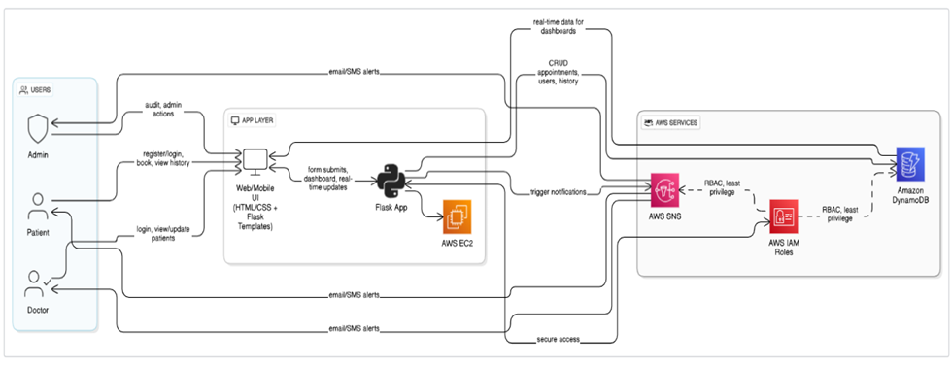

AWS ARCHITECTURE

Entity Relationship (ER)Diagram:

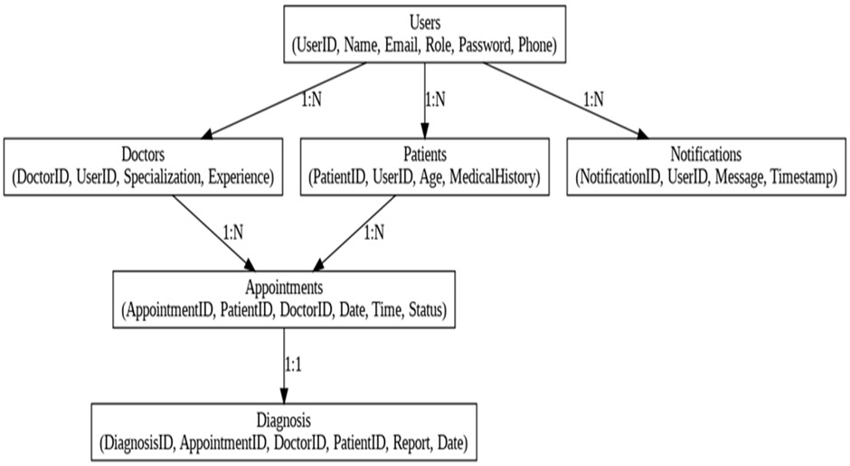

Pre-requisites:

1. AWS Account Setup:  
   <https://docs.aws.amazon.com/accounts/latest/reference/getting-started.html>
2. AWS IAM (Identity and Access Management):  
   <https://docs.aws.amazon.com/IAM/latest/UserGuide/introduction.html>
3. AWS EC2 (Elastic Compute Cloud):  
   <https://docs.aws.amazon.com/AWSEC2/latest/UserGuide/concepts.html>

1. AWS DynamoDB:   
   [https://docs.aws.amazon.com/amazondynamodb/Introduction.html](https://docs.aws.amazon.com/amazondynamodb/latest/developerguide/Introduction.html)
2. Amazon SNS:   
   <https://docs.aws.amazon.com/sns/latest/dg/welcome.htm>

1. Git Documentation:   
   <https://git-scm.com/doc>

7.VS Code Installation: (download the VS Code using the below link or you can get that in Microsoft store)  
<https://code.visualstudio.com/download>

Project WorkFlow:

1. AWS Account Setup and Login

Activity 1.1: Set up an AWS account if not alreadydone. Activity 1.2: Log in to the AWS Management Console

1. DynamoDB Database Creation and Setup

Activity 2.1: Create a DynamoDB Table.

Activity 2.2: Configure Attributes for User Data and Book Requests.

1. SNS Notification Setup

Activity 3.1: Create SNS topics for book requestnotifications.

Activity 3.2: Subscribe users and librarystaff to SNS email notifications.

1. Backend Development and Application Setup

Activity 4.1:Develop the BackendUsing JavaScript.

Activity 4.2: Integrate AWS Services Using boto3.

1. IAM Role Setup

Activity 5.1: Create IAM Role

Activity 5.2: Attach Policies

1. EC2 Instance Setup

Activity 6.1: Launch an EC2 instanceto host the JavaScript application.

Activity 6.2: Configure securitygroups for HTTP, and SSH access.

1. Deployment on EC2 Activity 7.1:Upload JavaScript Files
2. Activity 7.2: Run the JavaScript App

1. Testing and Deployment

Activity 8.1: Conduct functional testing to verify user registration, login, book requests,and notifications.

Milestone 1: AWS AccountSetup and Login

* 1. Activity 1.1: Set up an AWS account if not alreadydone.
     1. 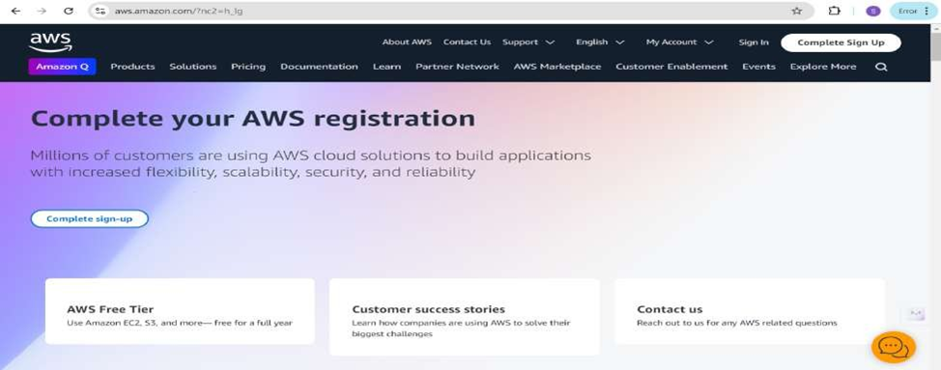Sign up for an AWS accountand configure billingsettings.

* 1. Activity 1.2: Log in to the AWS Management Console

* + 1. After setting up your account,log in to the [AWS Management Console](https://aws.amazon.com/console/).

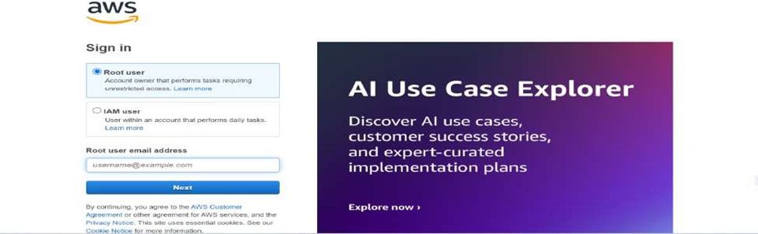

Milestone 2: DynamoDBDatabase Creation and Setup

* 1. Activity 2.1:Navigate to the DynamoDB
     1. In the AWS Console, navigateto DynamoDB and click on create tables.

* + 1. 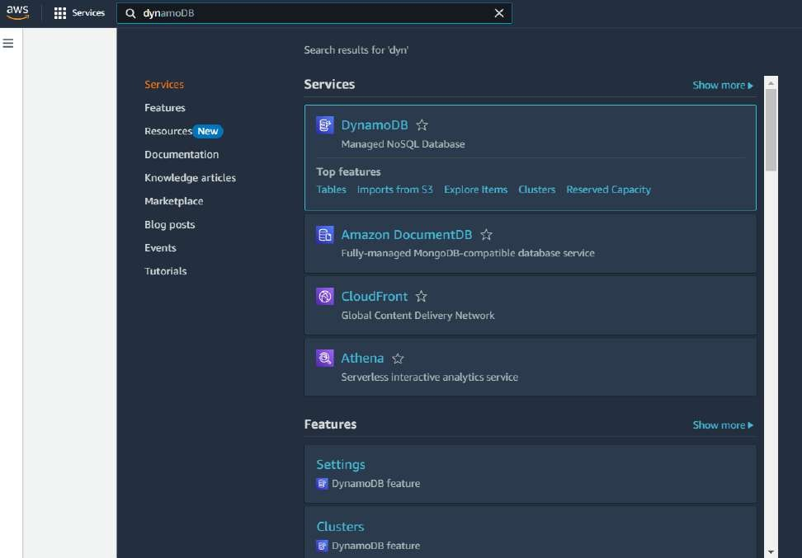

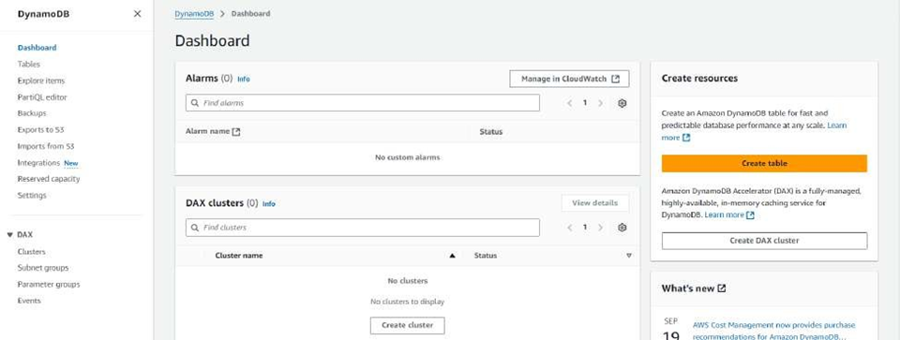

* 1. Activity 2.2:Create a DynamoDBtable for storingregistration details and book requests.
     1. Create Users table with partition key “Email” with type String and click on create tables.

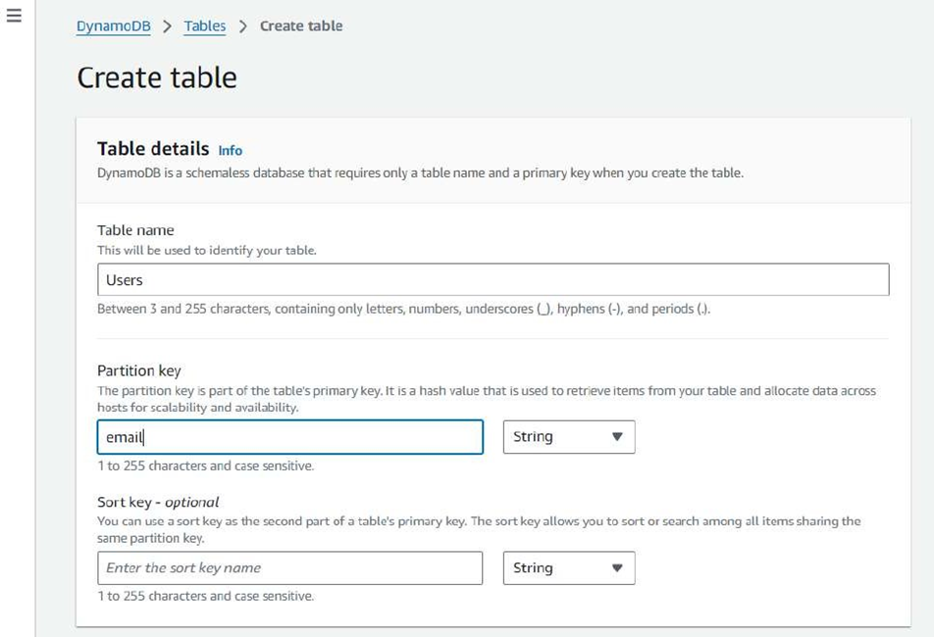

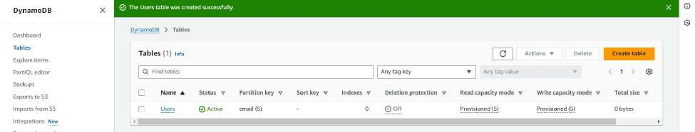

* + 1. Follow the same steps to create a requests tablewith Email as the primary key for book requests data.
    2. 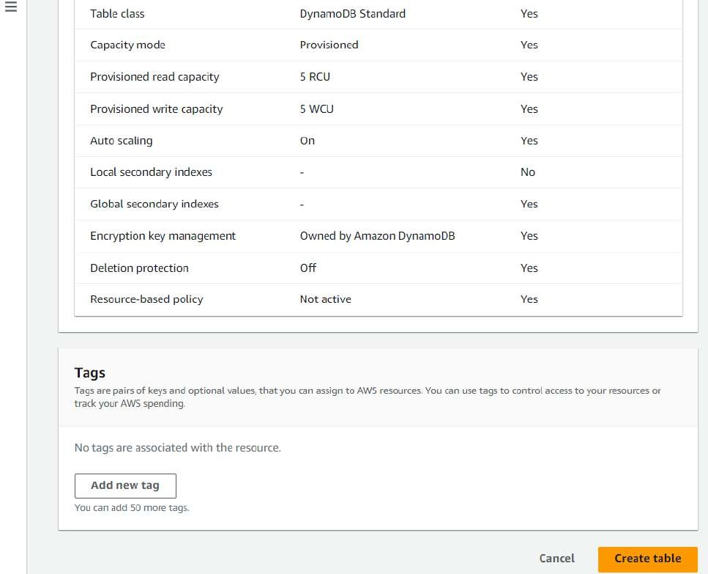

" DynamoDB \ Tables } Create table

retrieve items from your table and allocate data across

|  |
| --- |
| email |

1 ta 255 characters and case sensitive.

You can use a sort key as the second part of a tabte's primary key. The sort key allows you to sort or search among all rtems sharing the

|  |
| --- |
| Enter the sort key nome |

same partition key.

4 to 255 characters and case sensitive.

DynamoDB \ Tables } Create table

Createtable

**Table details** inio

DynamoDB is a schemaless database that requires only a table name and a primary key when you create the table.

Tablename

This will be used to identify your table.

# Smart Internz

|  |
| --- |
| Requests |

Between 3 and 2S5 char acters, curyLaJning unly letters, rJumLt s, uryderscores , hmheris (-[, and p@iods (.).

Partition key

The partition key ispart of the table's primar'/ key. It isa hash value that is used to retrieve items from your table and allocate data across

|  |
| --- |
| email |

1 ta 255 characters and case sensitive.

You can use a sort key as the second part of a tabte's primary key. The sort key allows you to sort or search among all rtems sharing the

|  |
| --- |
| *Enter the sort key nome* |

same partition key.

4 to 255 characters and case sensitive.

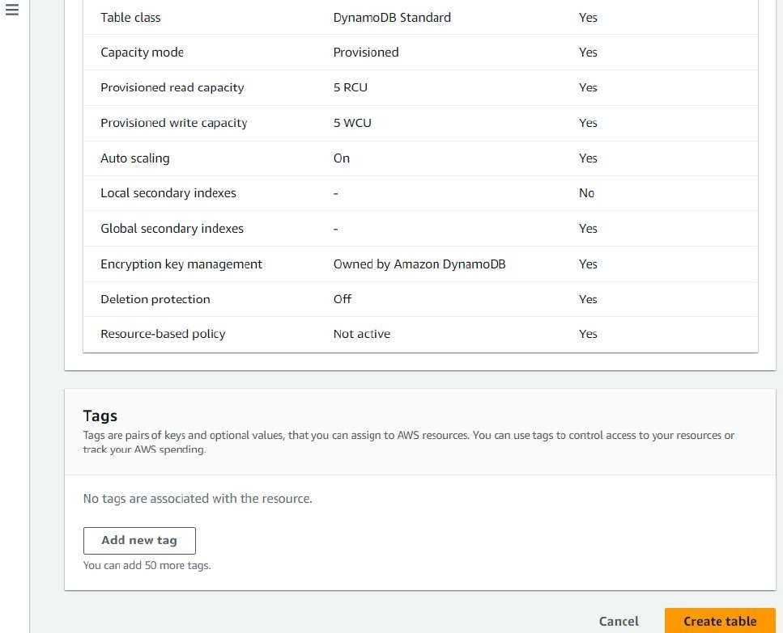

|  |
| --- |
|  |

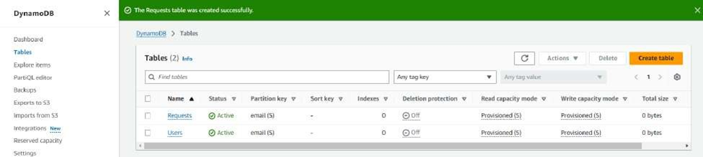

Milestone 3: SNS Notification Setup

* 1. Activity 3.1: Create SNS topics for sending email notifications to users and library staff.

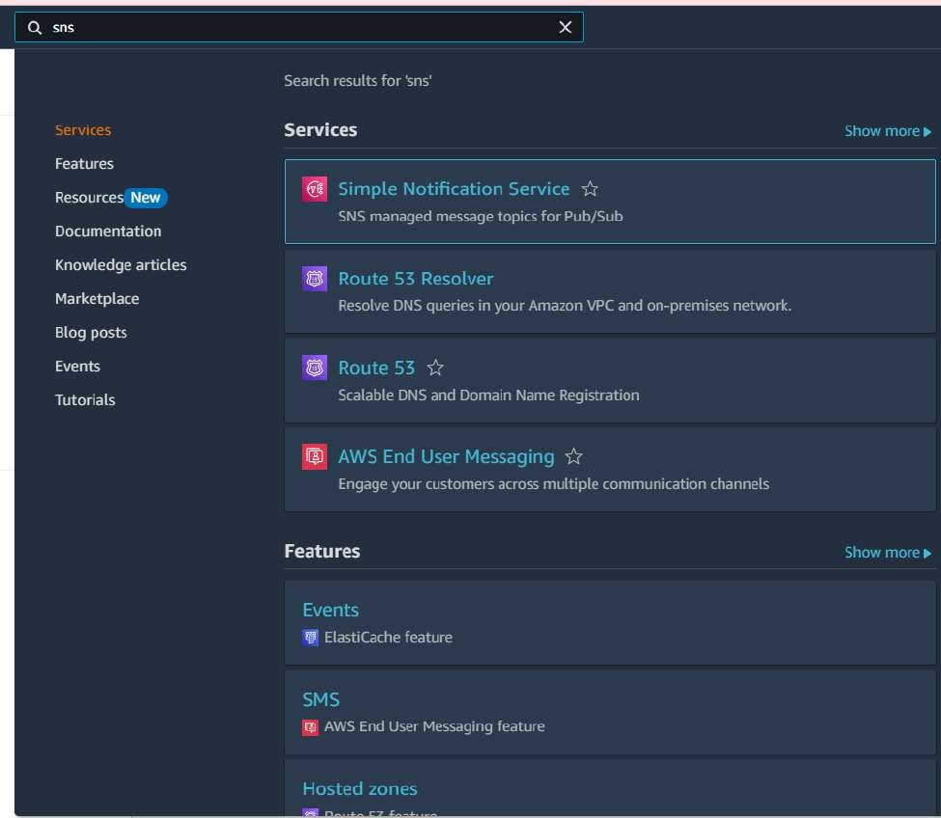

* + 1. In the AWS Console,search for SNS and navigateto the SNS Dashboard.

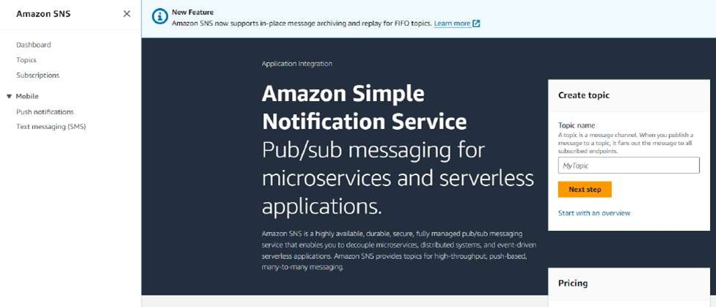

* + 1. Click on Create Topic and choosea name for the topic.

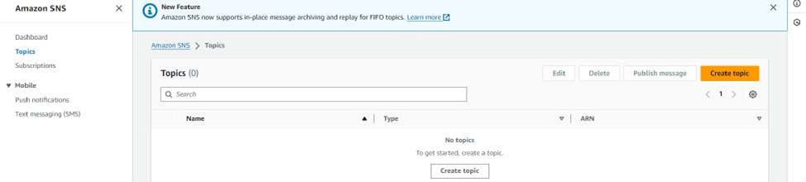

* + 1. Choose Standard type for general notification use cases and Click on Create Topic.

Amazon 5N5 \ Topics Createtopic

Create topic

**Details**

Type trrfo

Topic type cannot be modified atter topic is created

# Smart Internz

|  |
| --- |
| O FJFO (first-in, first-out)   1. Strictly—preserved message ordering 2. Mactly-onEe message delivery 3. High throughput, up to ZOO publishes/second 4. Subscription protocol: SQS |

|  |
| --- |
| @ Standard  Best-effcrt message ordering at-least once message delivery  Highest throughput in publishes/second Subscription protocols: SQS, Lambda, HTTP, SI IS, email, mobile application endpoints |

Name

|  |
| --- |
| BookRequeStNotificatiDr6 |

Maximum 256 characters. Can include alphanurr+eric characters, hyphens (-) and underscores M.

Display name - optional lrrfo

To use this topic with 5M5 subscriptions, enter a display name. Only the first 10 characters are displayed in an Si iS message.

Maximum 1 00 characters.

|  |
| --- |
|  |

|  |
| --- |
|  |

* + 1. Configure the SNS topic and note down the Topic ARN.
    2. 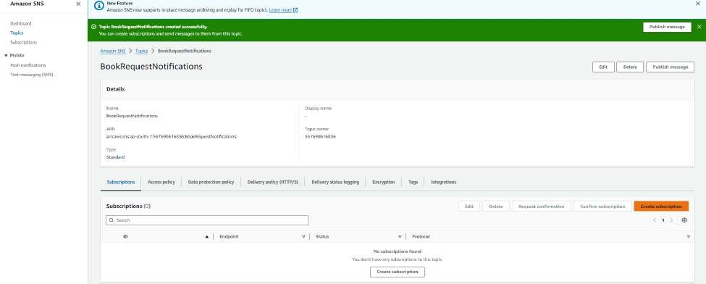

* 1. Activity 3.2: Subscribe users and staff to relevantSNS topics to receive real-time notifications when a book request is made.

* + 1. Subscribe users (or admin staff) to this topic via Email.When a book request is made, notifications will be sent to the subscribed emails.

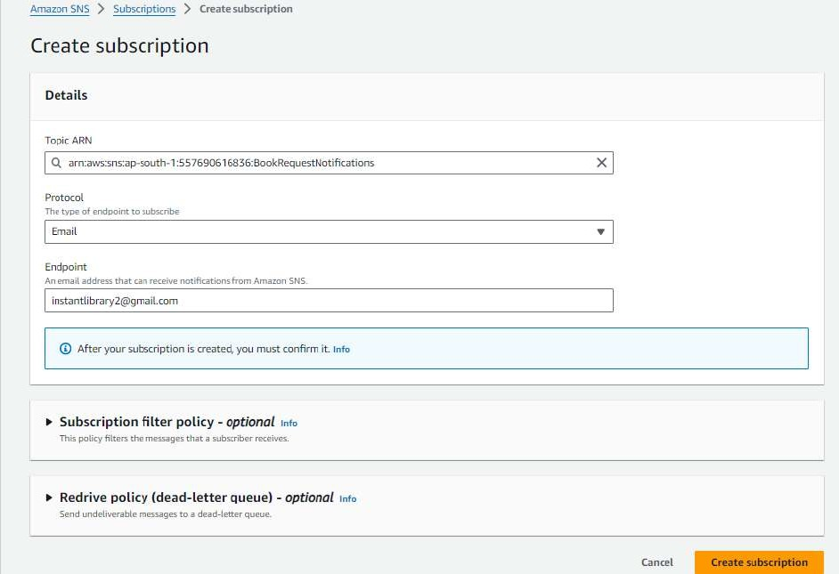

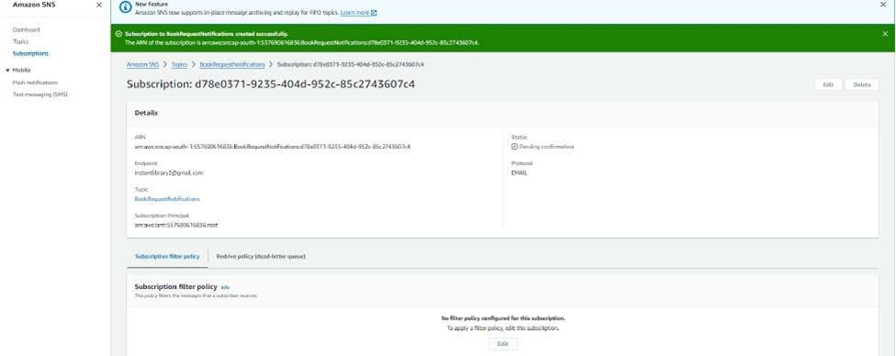

* + 1. After subscription requestfor the mail confirmation

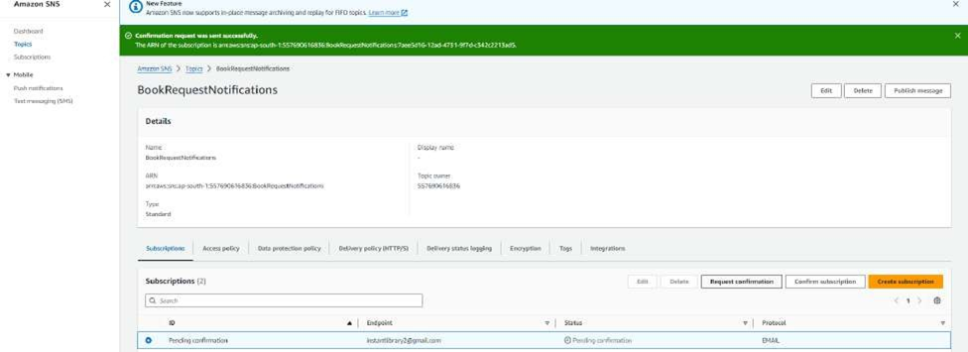

* + 1. Navigate to the subscribed Email account and Click on the confirmsubscription in the AWS Notification- Subscription Confirmation mail.

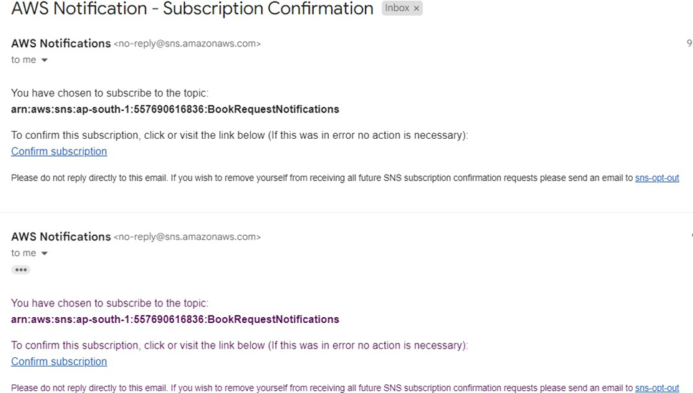

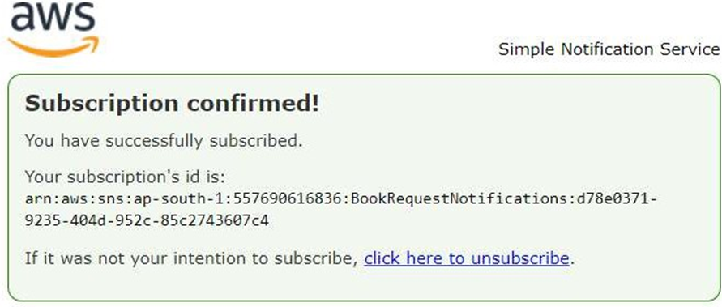

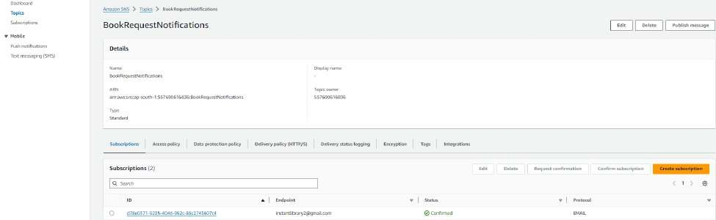

* + 1. Successfully done with the SNS mail subscription and setup, now store the ARN link.

Milestone 4:Backend Development and Application Setup

* 1. Activity 4.1: Developthe backend usingJavaScript
     1. File Explorer Structure

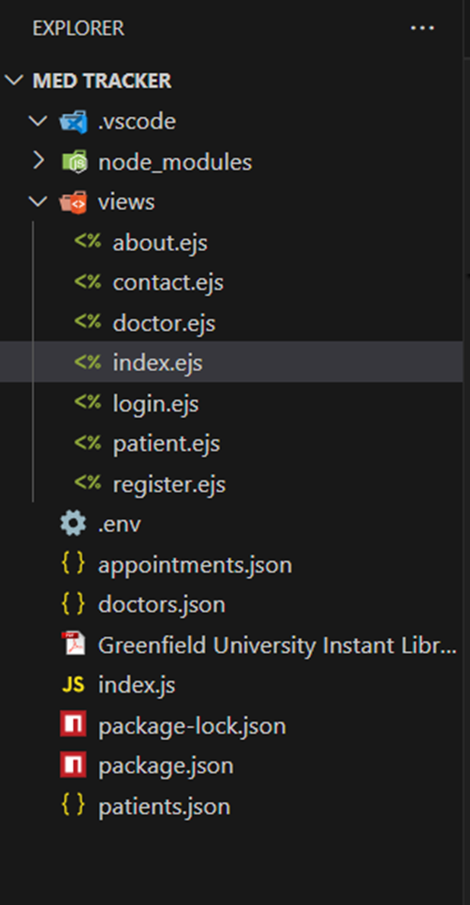

Description: set up the INSTANT LIBRARY project with an index.js file, a public/ folder for assets, and a views/ directory containing all required HTML pages like home, login, register, subject-specific pages (e.g., computer_science.html, data_science.html), and utility pages (e.g., request-form.html, statistics.html).

Description of the code :

* 1. Node js ( Express ) Initialization

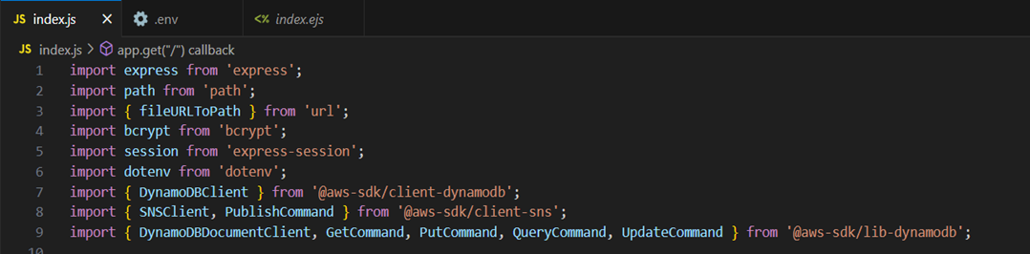

Description: import essential librariesincluding Express utilitiesfor routing, Boto3 for DynamoDB operations, SMTP and email modules for sending mails, and Bcrypt for password hashing and verification

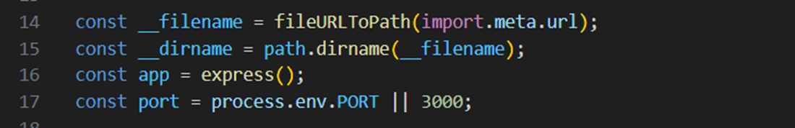

Description: initialize the Flask application instanceusing __filename to get the path of the directory and app is used to get express to start building the web app.

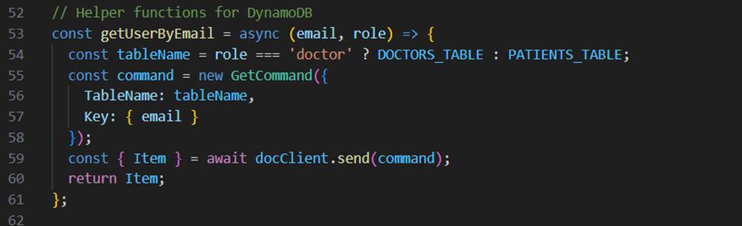

* 1. Dynamodb Setup:



Description: initialize the DynamoDBresource for the ap-south-1 regionand set up access to the Users and Requests tables for storing user details and book requests.

* 1. SNS Connection

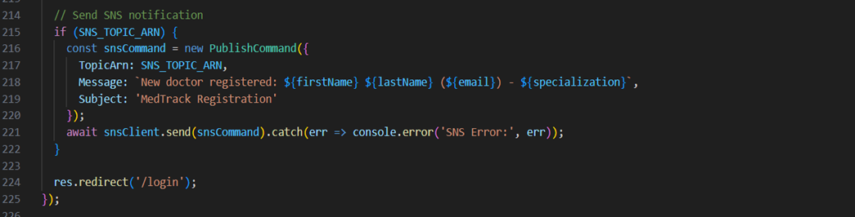

Description: Configure SNS to send notifications when a book request is submitted. Paste your stored ARN link in the sns_topic_arn space, along with the region_name where the SNS topic is created. Also, specify the chosen email service in SMTP_SERVER (e.g., Gmail, Yahoo, etc.) and enter the subscribed email in the SENDER_EMAIL section.Create an ‘App password’ for the email ID and store it in the SENDER_PASSWORD section.

* 1. Routes for Web Pages

1. Home Route:

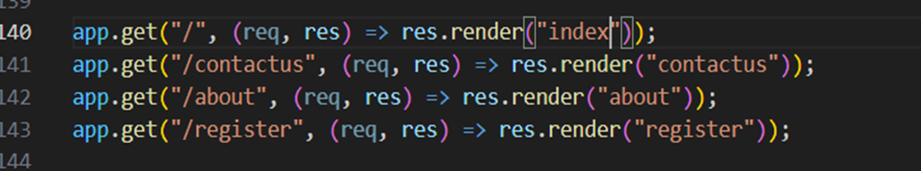

Description: define the home route / to automatically redirect users to the register page when they access the base URL.

* 1. Register Route:

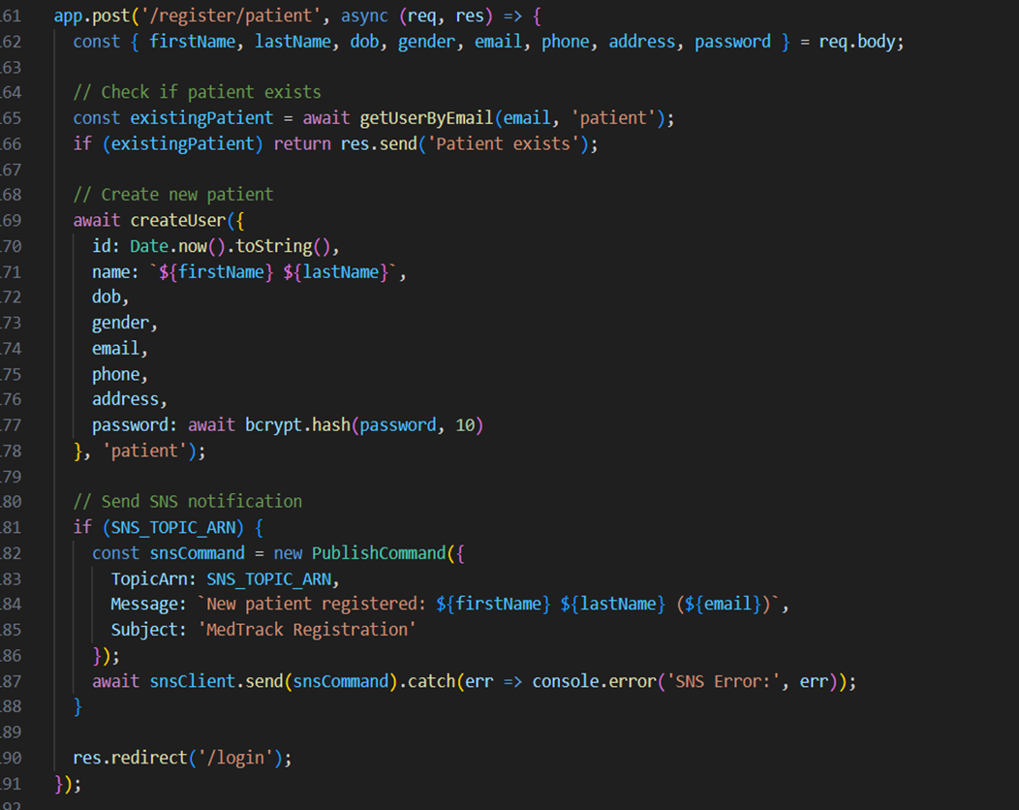

Description: define /register route to validate registration form fields, hash the user password using Bcrypt, store the new user in DynamoDB with a login count, and send an SNS notification on successful registration

1. login Route (GET/POST):

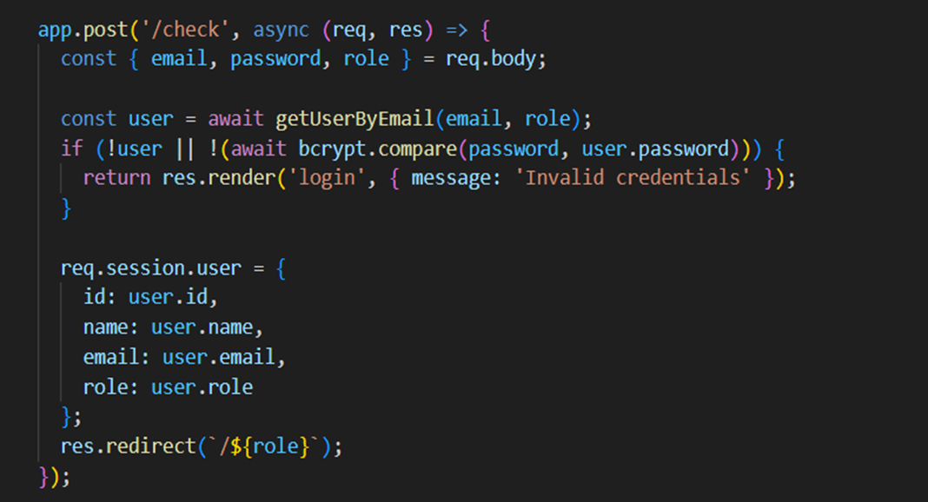

Description: define /login route to validate user credentials against DynamoDB, check the password usingBcrypt, update the login counton successful authentication, and redirect users to the home page

1. Home, E- book buttons and subject routes:

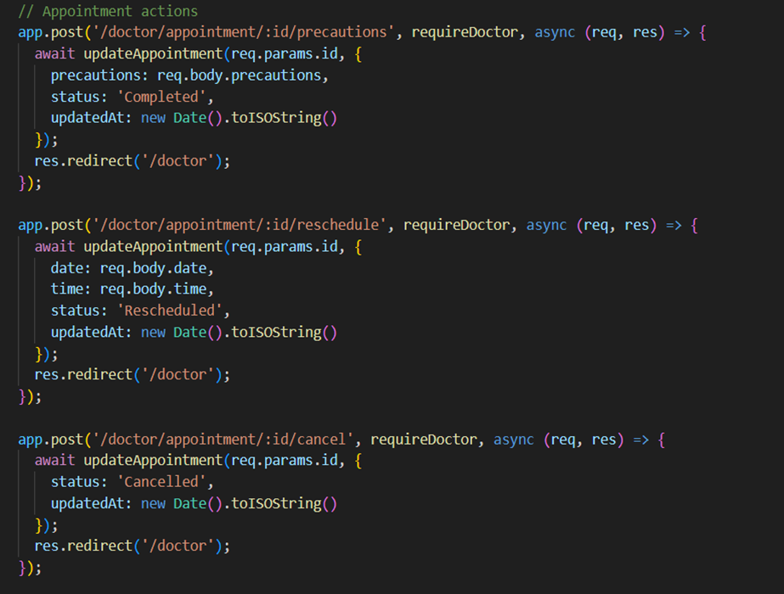

Description: define /home-page to render the main homepage,/ebook-buttons to handle subject selection and redirection, and /<subject>.html dynamic route to render

subject-specific pages.

* 1. Request Routes:

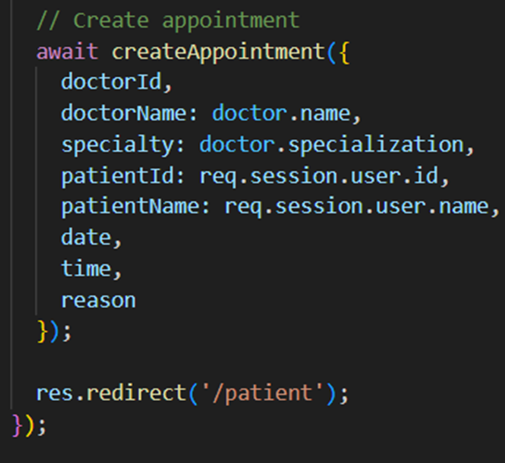

Description: define /request-form route to capture book request details from users, store the request in DynamoDB, send a thank-you email to the user, notify the admin, and confirmsubmission with a success message.

Exit Route:

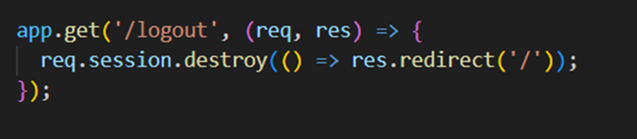

Description: define /exit routeto render the exit.html page when the user choosesto leave or close the application.

Deployment Code:

Description: start the Flask serverto listen on all networkinterfaces (0.0.0.0) at port 80

with debug mode enabled for development and testing.

Milestone 5: IAM Role Setup

1. Activity 5.1:Create IAM Role.
2. In the AWS Console,go to IAM and createa new IAM Role for EC2 to interact with DynamoDB and SNS.

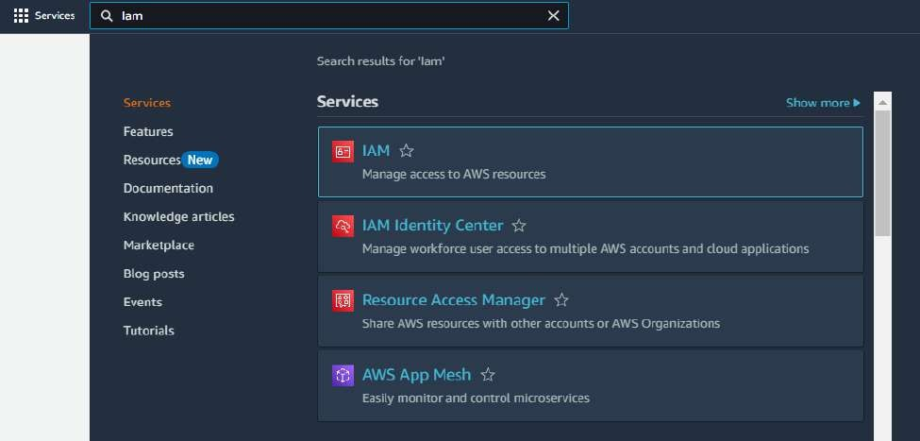

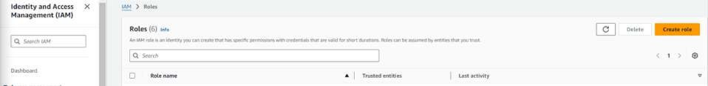

1. Activity 5.2: AttachPolicies.

Attach the following policiesto the role:

* 1. AmazonDynamoDBFullAccess: Allows EC2 to perform read/write operations on DynamoDB.
  2. AmazonSNSFullAccess: Grants EC2 the abilityto send notifications via SNS.

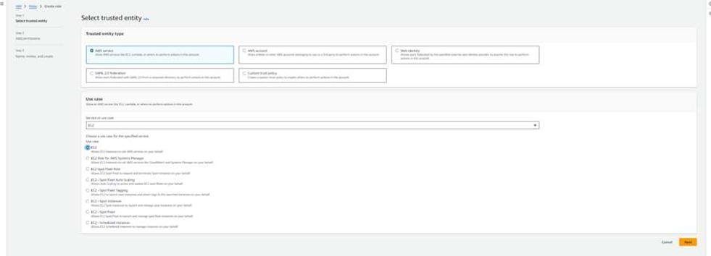

Milestone 6: EC2 Instance Setup

1. Note: Load your index.jsand Html files into GitHubrepository.

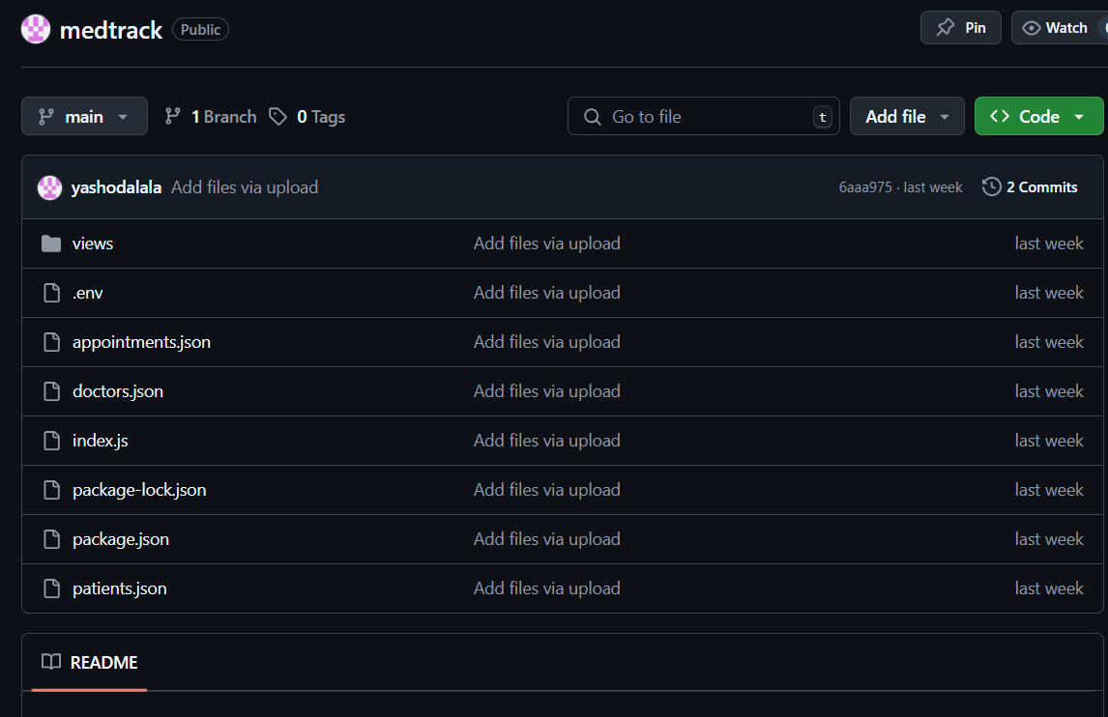

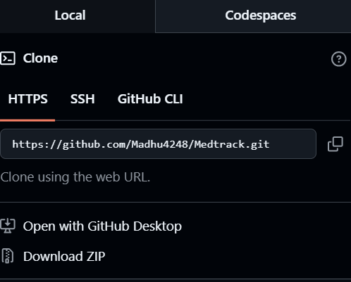

1. Activity 6.1: Launchan EC2 instance to host the Flask application.

* 1. Launch EC2 Instance
     1. In the AWS Console, navigateto EC2 and launch a new instance.

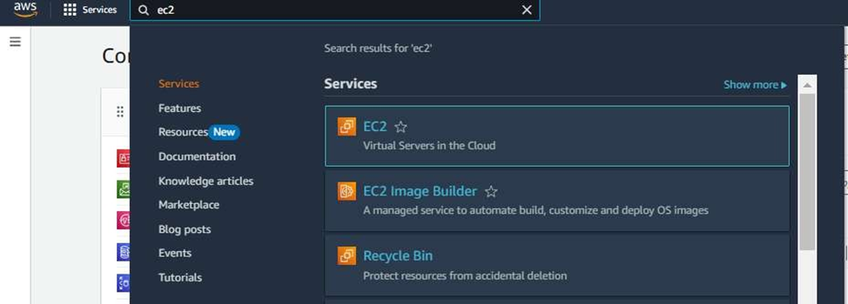

1. Click on Launchinstance to launchEC2 instance

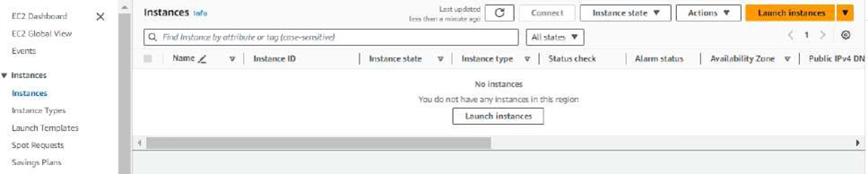

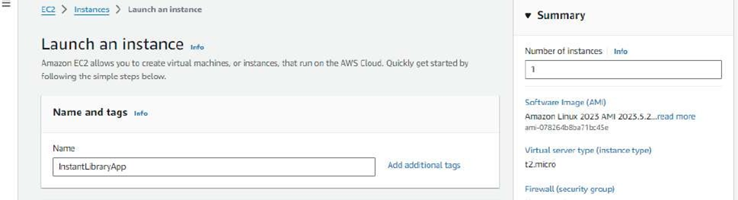

* 1. Choose Amazon Linux 2 or Ubuntu as the AMI and t2.micro as the instancetype (free-tier eligible).

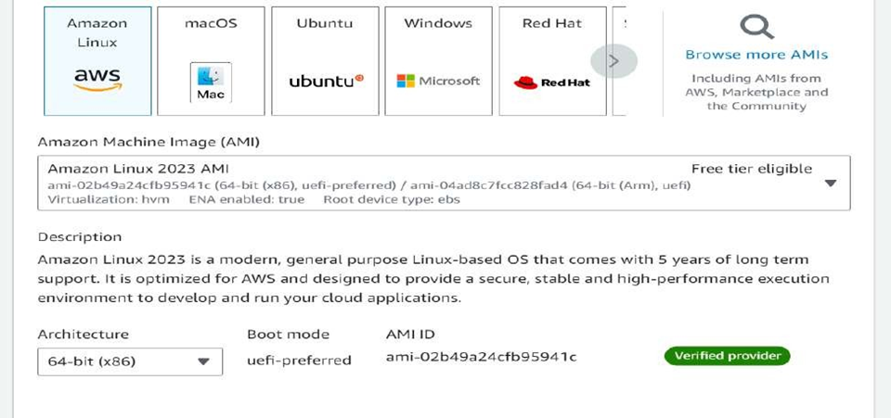

1. Create and downloadthe key pair for Serveraccess.

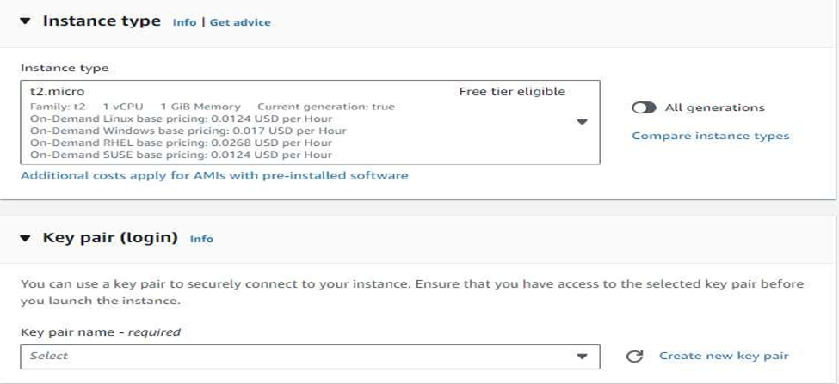

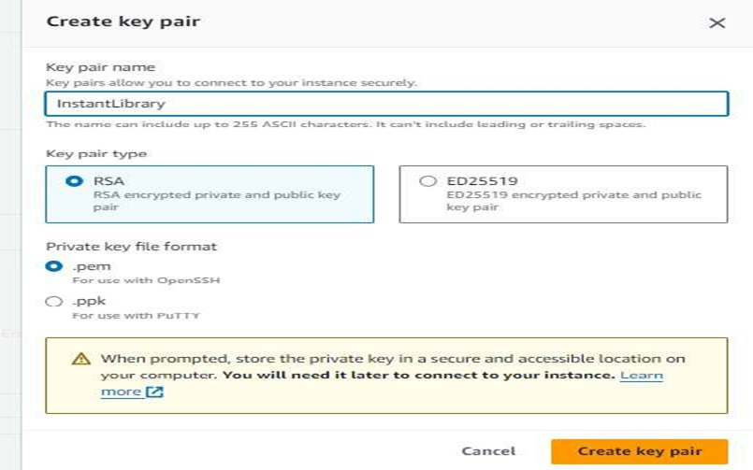

1. Activity 6.2:Configure securitygroups for HTTP,and SSH access.

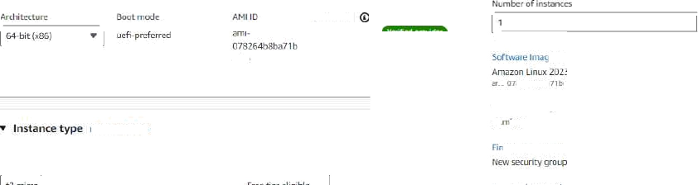

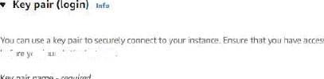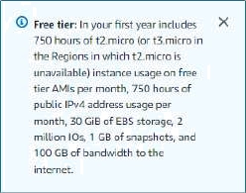

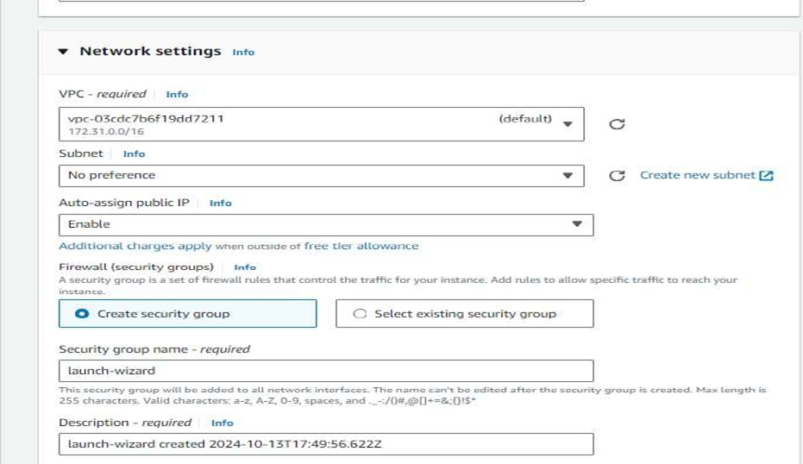

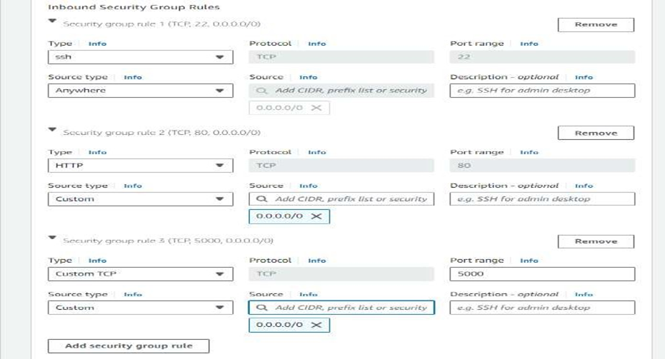

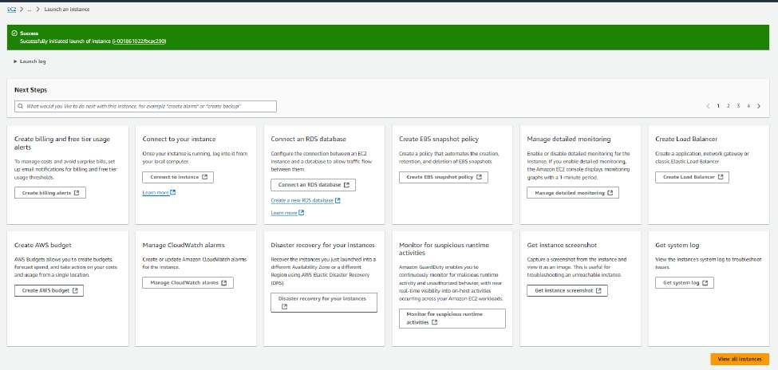

1. To connect to EC2 using EC2 Instance Connect, start by ensuring that an IAM role is attached to your EC2 instance. You can do this by selecting your instance, clicking on Actions, then navigating to Security and selecting Modify IAM Role to attach the appropriate role. After the IAM role is connected, navigate to the EC2 section in the AWS Management Console. Select the EC2 instance you wish to connect to. At the top of the EC2 Dashboard, click the Connect button. From the connection methods presented, choose EC2 Instance Connect. Finally, click Connect again, and a new browser-based terminalwill open, allowing you to access your EC2 instance directly from your browser.

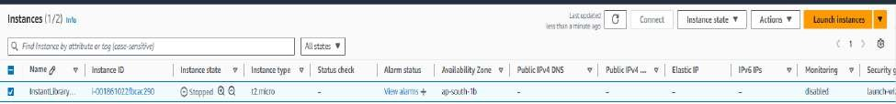

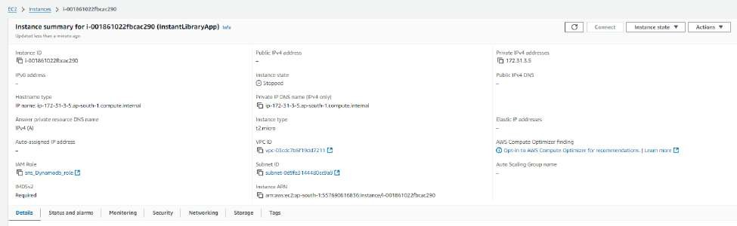

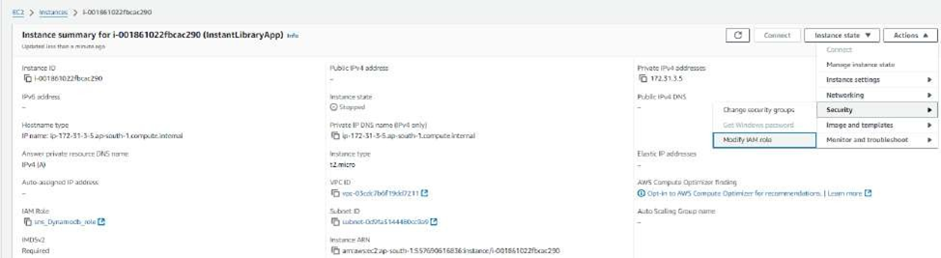

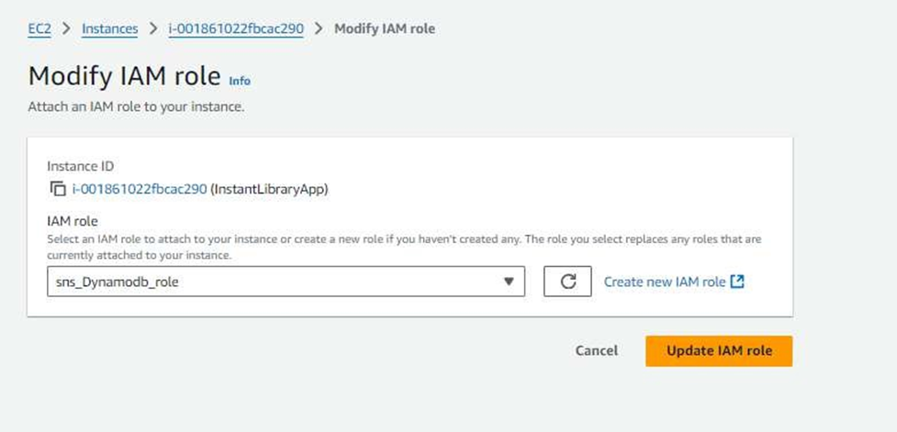

1. Now connect the EC2 with the files

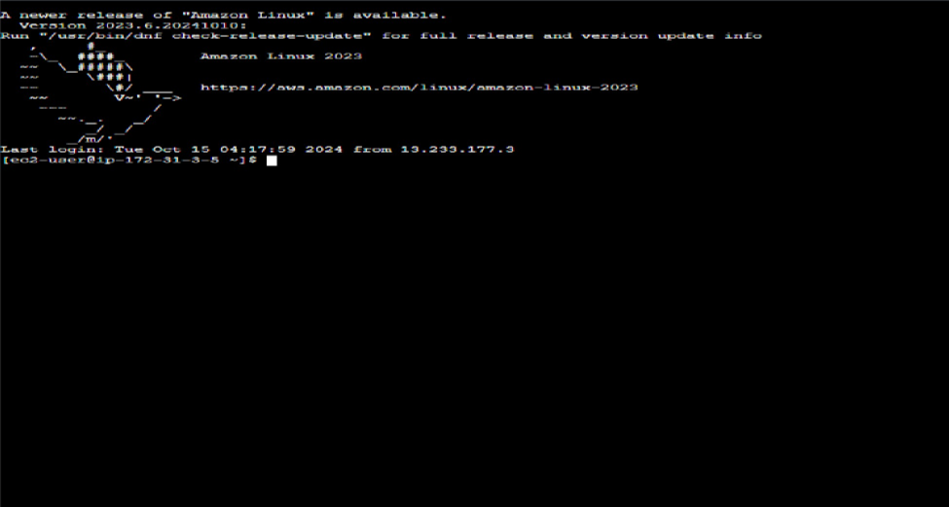

Milestone 7: Deployment on EC2

Activity 7.1: Install Softwareon the EC2 Instance

# Update system and install Node.js, npm, git

sudo yum update -y

curl -fsSL https://rpm.nodesource.com/setup_18.x | sudo bash -

sudo yum install -y nodejs git

Activity 7.2:Clone Your Flask Projectfrom GitHub

Clone your projectrepository from GitHubinto the EC2 instance using Git.

# Clone your Node.js project from GitHub

git clone https://github.com/prasannakumar133/MedTrack-repo.git

# Install project dependencies

npm installNote: change your-github-username and your-repository-name with your

1. This will downloadyour project to the EC2 instance.

To navigateto the project directory, run the following command:

cd MedTrack-repo

Once inside the projectdirectory, configure and run the Nodejs application by executing the following command with elevated privileges:

Run the Flask Application

# Install project dependencies

npm install

# Install PM2 globally to keep the app running

sudo npm install -g pm2

# Start the app using PM2 (replace 'app.js' with your entry point if different)

pm2 start app.js

pm2 save

pm2 startup

# Copy and run the command shown by the previous line (for startup on reboot)

# (Optional) Allow the app port (3000) through firewall

sudo firewall-cmd --zone=public --permanent --add-port=3000/tcp

sudo firewall-cmd --reload

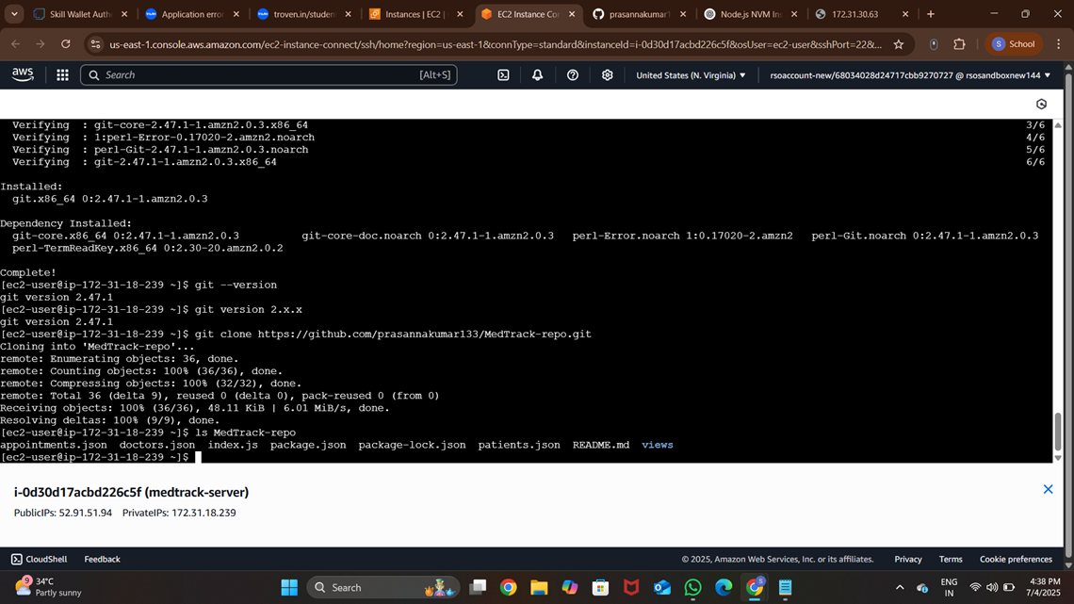

Verify the Nodejs app is running: Done! Your app is running at http://<your-ec2-public ip>:3000

Run the Nodejs app on the EC2 instance

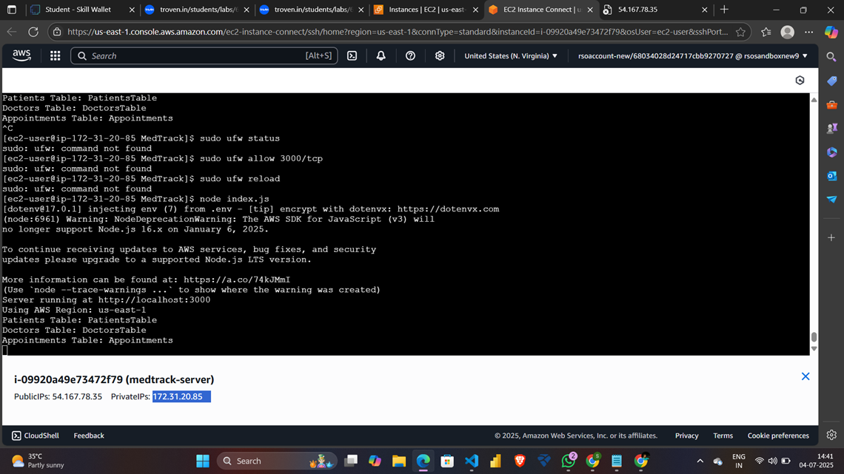

Access the website through:

PublicIPs:http://52.91.51.94:3000/

Milestone 8: Testingand Deployment

1. Activity 8.1: Conduct functional testing to verifyuser registration, login, requests, and notifications.

Login Page :

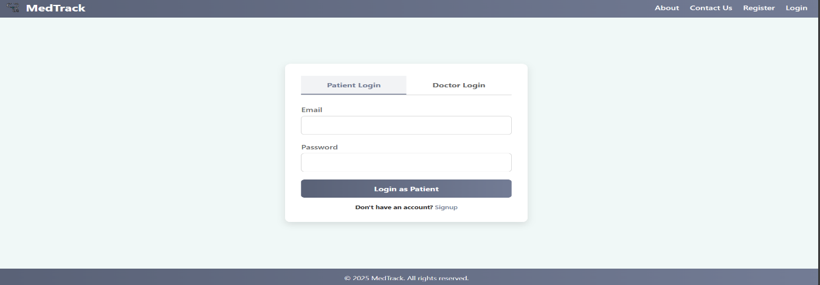

Register Page :

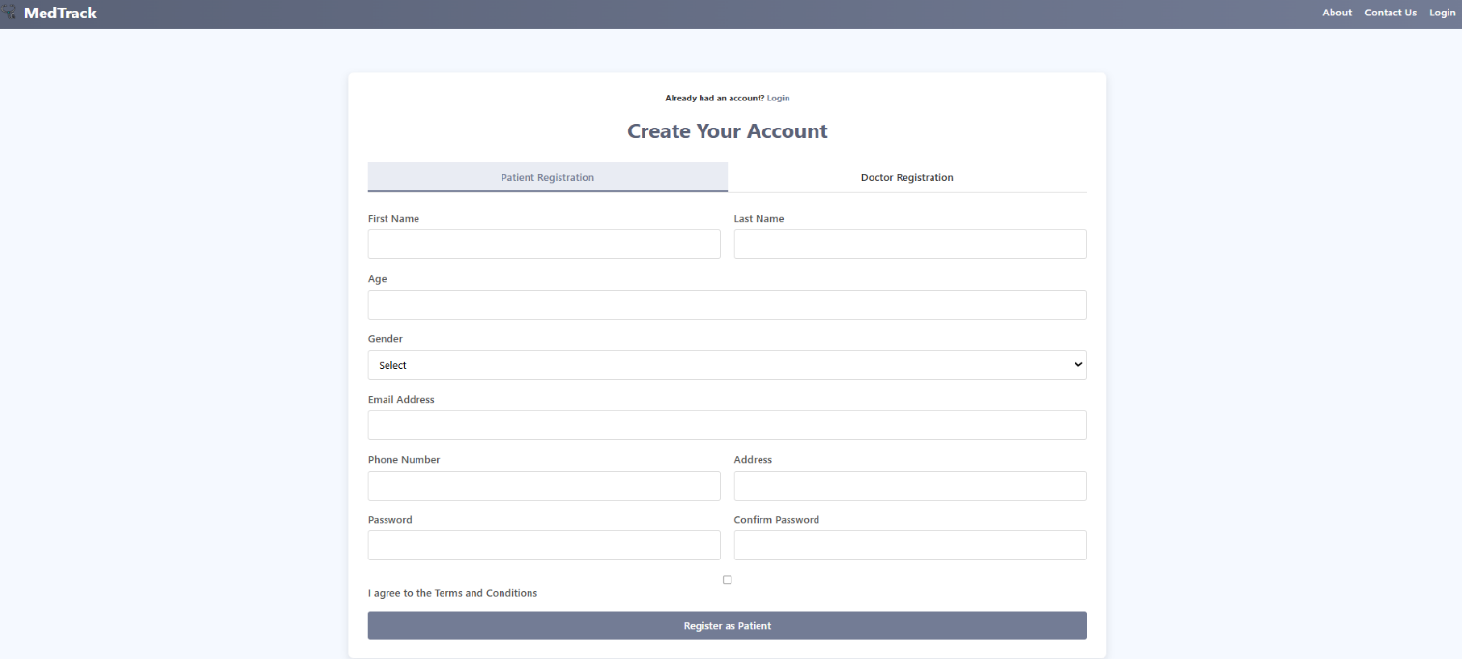

Home Page :

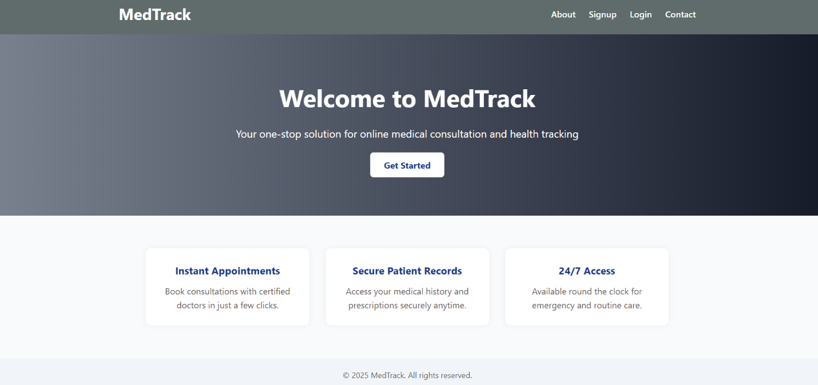

About Us Page :

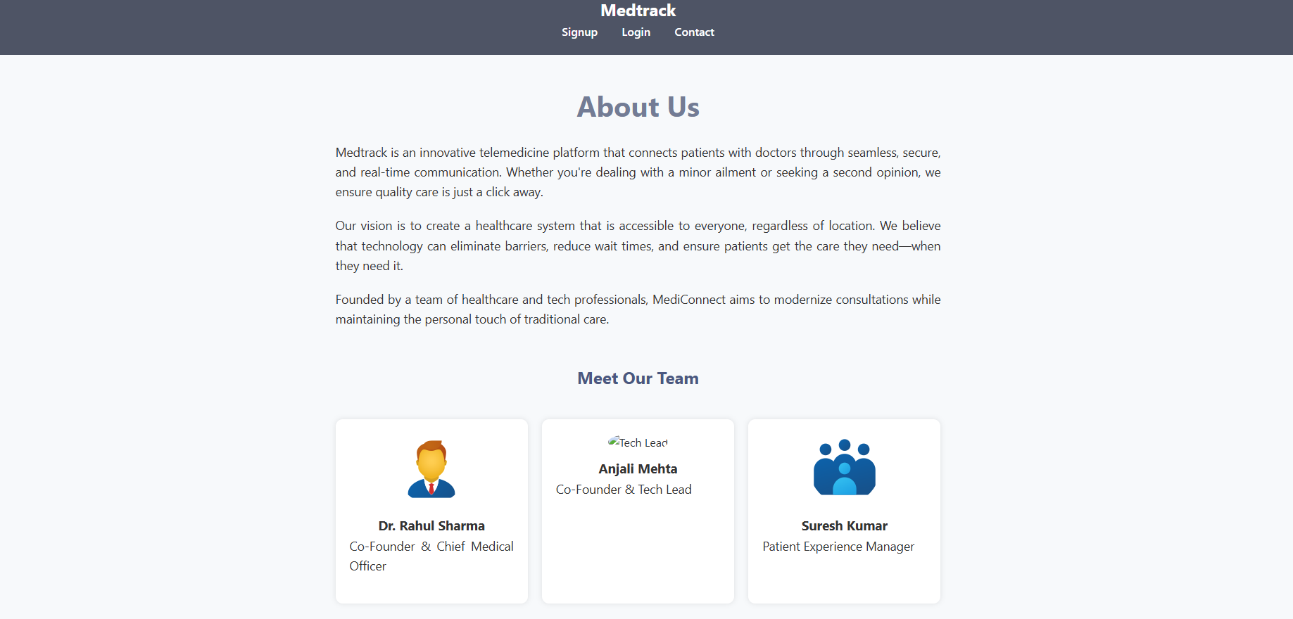

Contact Us Page : 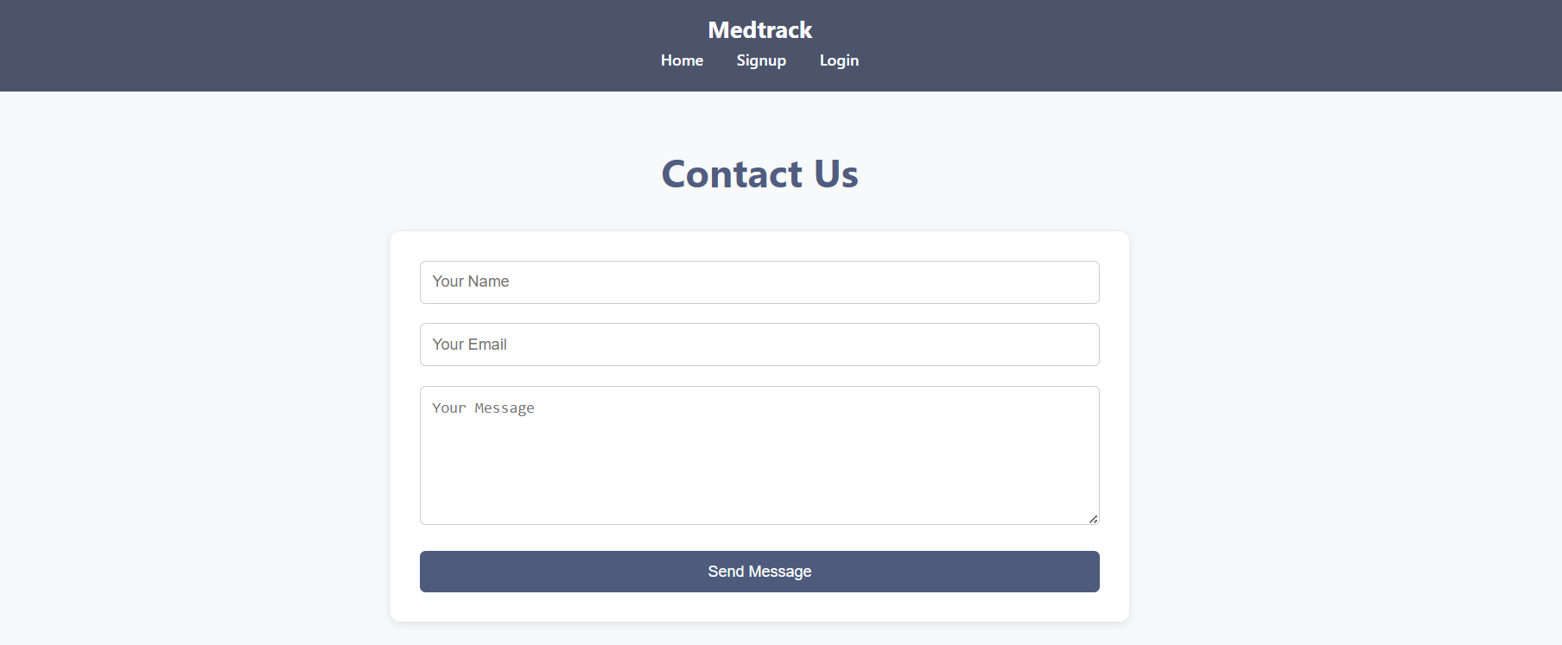

Conclusion :

MedTrack illustrates the power of leveraging AWS cloud services to build a modern, reliable healthcare management system. By combining Amazon EC2 for scalable application hosting, DynamoDB for fast and flexible data storage, SNS for instant notifications, and IAM for fine-grained access control, MedTrack ensures secure, efficient, and responsive healthcare operations.

The system streamlines the entire patient care process—from appointment scheduling and telemedicine

consultations to emergency access to records and automated alerts—reducing administrative overhead and improving the patient experience. With high availability, data encryption, and compliance-ready infrastructure, MedTrack empowers healthcare providers to focus on delivering quality care while maintaining trust and data security.

Overall, this project demonstrates how cloud-native solutions can transform traditional healthcare environments into agile, scalable, and patient-centric ecosystems.